Miles Lee

November 13, 2019

Microsite: Sourdough

This will be a microsite on sourdough bread. It would be interesting to explore different textures (ie: flour, dough, the starter, baked bread) as full-page backgrounds.

Home

History

Preparation

Chemistry

Across the world

Sources

Creative Brief

Miles Lee

November 13, 2019

Project Title: Sourdough Bread Website

1. **Project Overview**

This will be a microsite on sourdough bread. The goal is to provide information about what sourdough is, its history, and how it’s made.

1. **Resources**

Copy is available on the [Sourdough Wikipedia page](https://en.wikipedia.org/wiki/Sourdough), as well as some images. For other images, you will want to use Google Images and recipe blogs/websites for in-progress steps as well.

1. **Audience**

This should be mostly informational, but if you’re a fan of sourdough bread, feel free to make a “Sourdough bread from different places, ranked” list to rank different sourdough breads you’ve tried from places like Boudin, Trader Joe’s, Aldi, Kayak’s, etc.

1. **Message**

I think sourdough is a bread that’s a little bit elusive in terms of how it’s made and why it has that tangy flavor. I’d like this site to sort of “de-mystify” sourdough bread.

1. **Tone**

The tone could be scientific/official if you’re more on the serious side of things, or more playful. Ultimately, the audience you’re targeting (ie: teens, adults, sourdough enthusiasts, aspiring bakers) is up to you, but **your tone should be appropriate for your audience.** I personally think it might be fun to have a more playful site with bold lettering for headers.

1. **Visual Style**

Again, this depends on the tone/audience you’re going for.

If you want to go the scientific/official route, you might have the visual style look something like a textbook (but hopefully not a boring one) with a white (or near-white) background and black text and more diagrammatical images (labeled like “Figure 1” “Figure 2,” etc).

For the playful route, I think [bright colors](https://maam.massart.edu/) and maybe patterns would be nice. One idea I had was to have different textures (ie: flour, dough, the starter, baked bread) as full-page backgrounds or bottom margins (ie: a bar that runs along the top/bottom/side with a static image) for different sections.

I **love** [sticky headers](https://www.w3schools.com/howto/howto_js_sticky_header.asp) and [sticky sidebars](https://www.w3schools.com/howto/howto_css_fixed_sidebar.asp).

**Please** don’t use Brandon Grotesque for the body copy. Also, try to refrain from using script fonts, unless it’s super legible and doesn’t look tacky (good script fonts are few and far between).

I’ve provided visual references starting on the next page.

1. **Visual References**

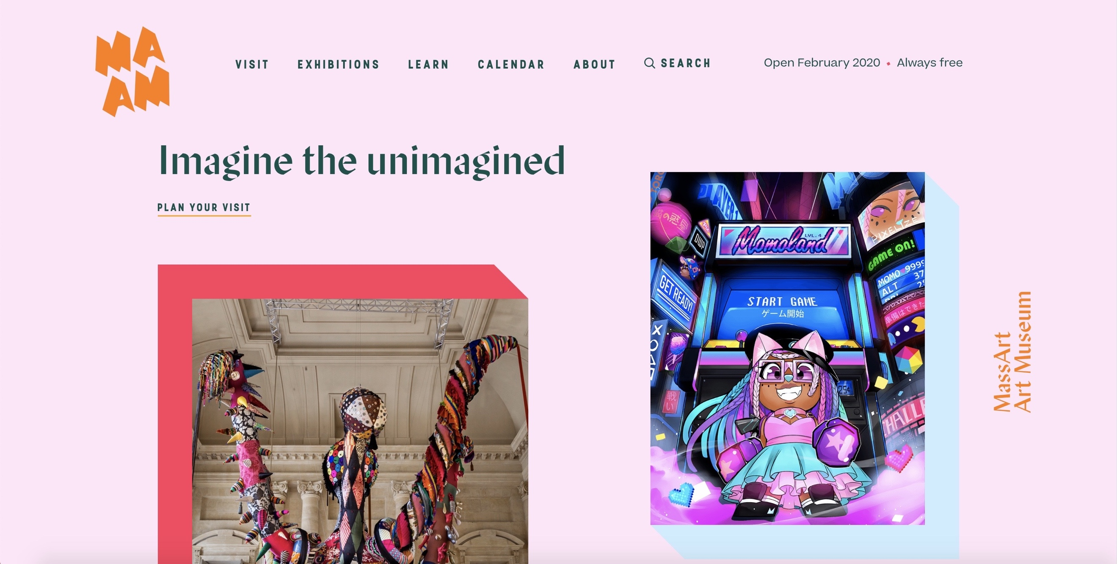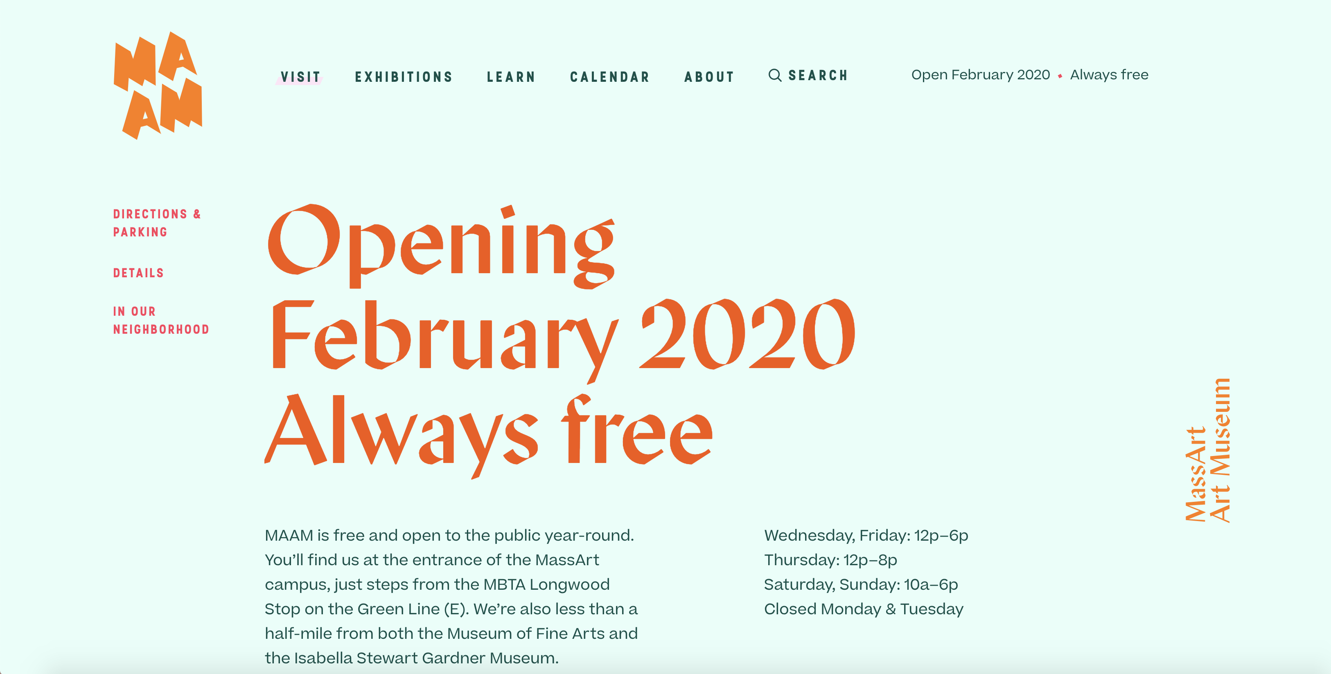

I REALLY love [this](https://maam.massart.edu/) website. I think the colors changing between each section is really nice. Obviously, please don’t make each page too different—use similar layouts, same fonts and pt sizes, etc. you hopefully know the drill.

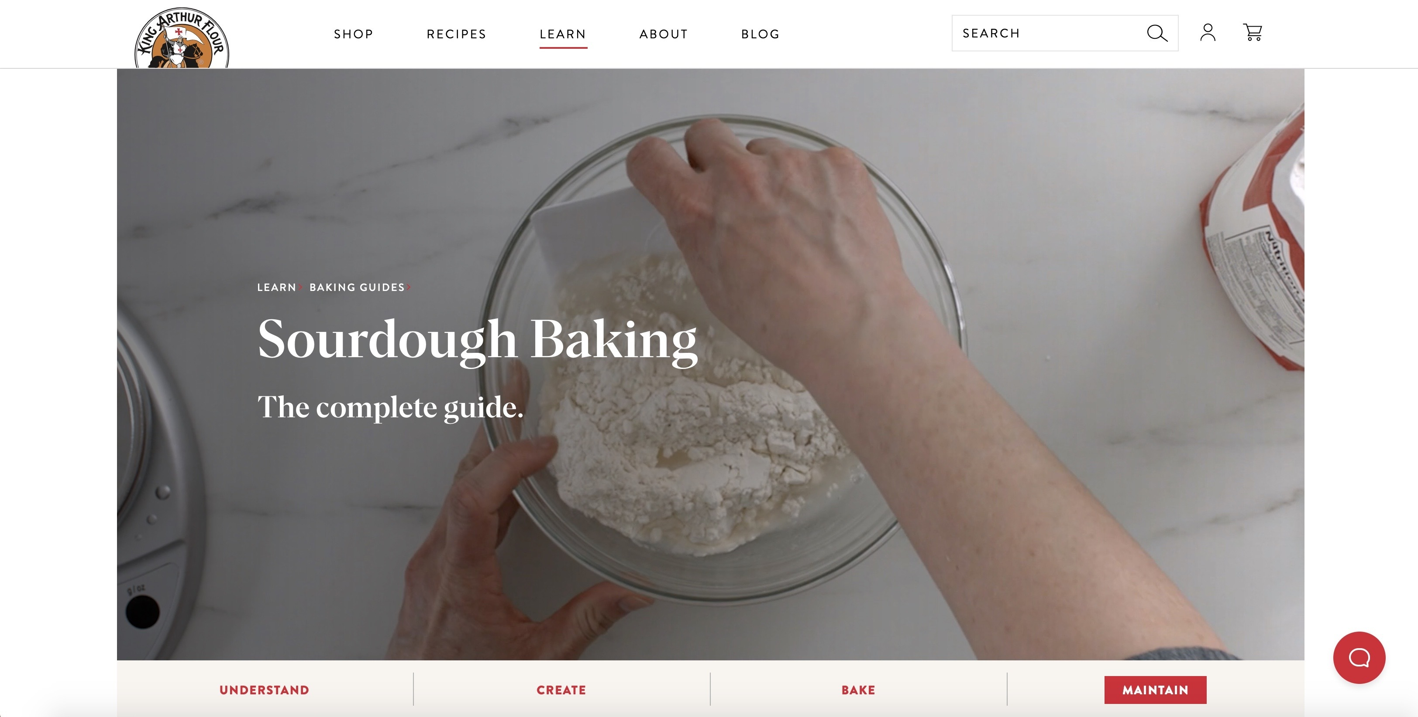



[This](https://www.kingarthurflour.com/learn/guides/sourdough/create) is a cool website about sourdough bread. I like the different sections at the top (“understand” “create” “bake” “maintain”) but I wish they were sticky (ie: when you scroll down, the header still stays at the top).

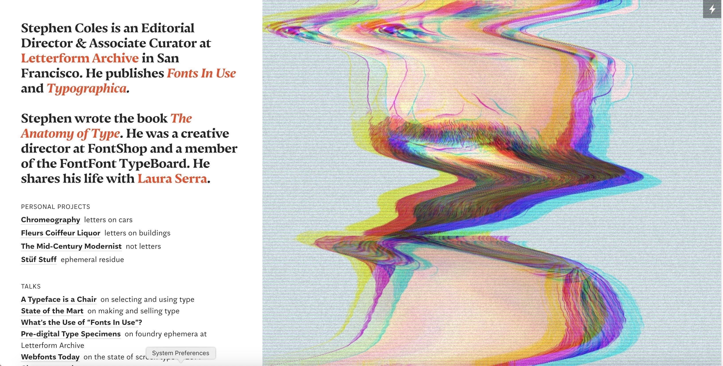

[This](https://stephencoles.org/) but a sidebar that’s less wide (try 30% or 25% maybe). I think a fixed, static image (or images that change when you reach a different section) in a sidebar like this would be cool.

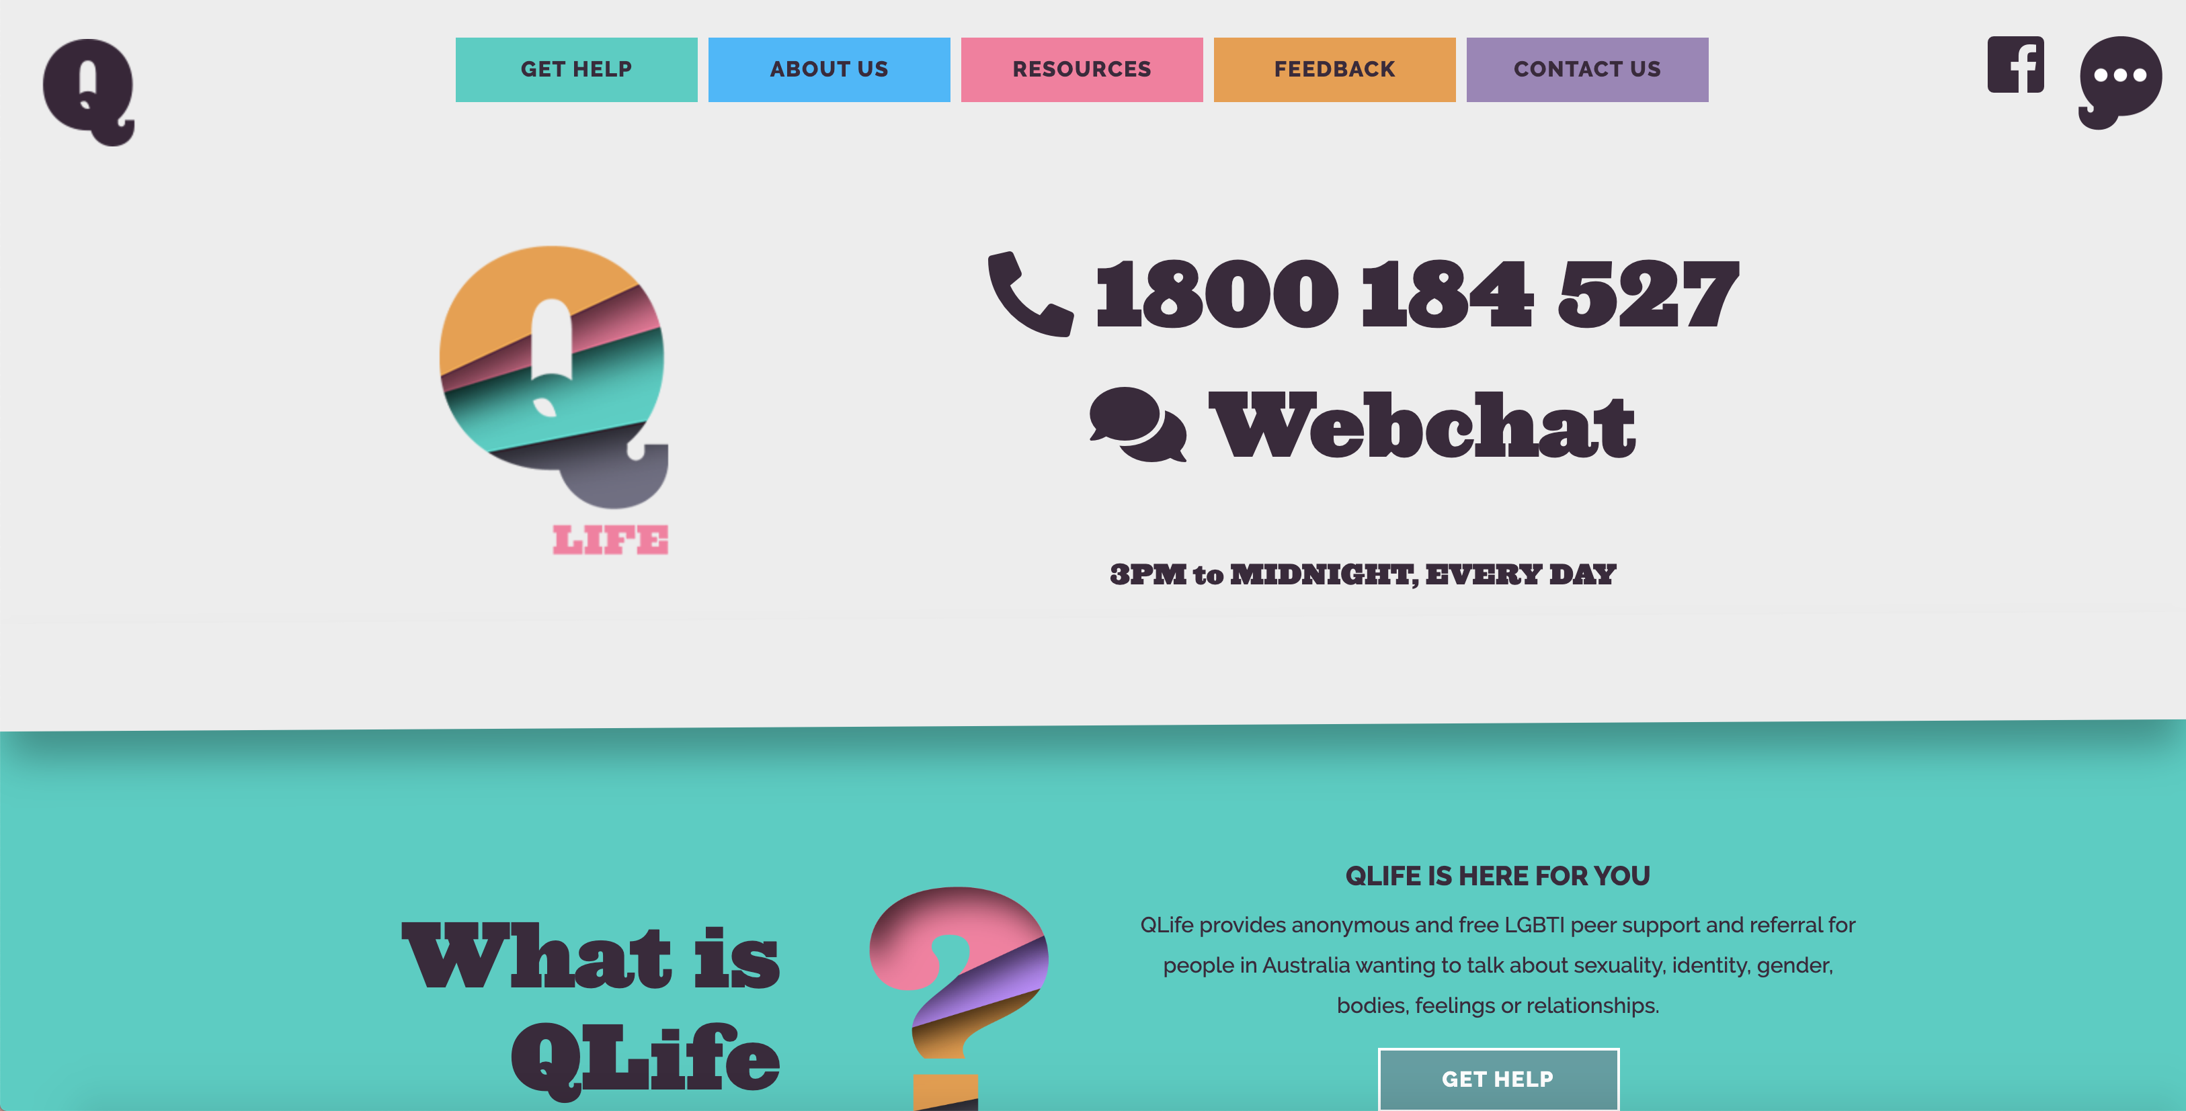

[This](https://qlife.org.au/) does a good job of being heavily styled but not extremely overwhelming. I enjoy the font and color choices. Don’t use drop shadows for sections like this does, though.

Initial Meeting Notes

Miles Lee (Creative Director) & Rob Hall (Designer)

November 13, 2019

Project Title: Sourdough Bread Website

* Rob will go with a playful feel. We looked at [this website](https://maam.massart.edu/about) for inspiration.
* He will try talked about a sticky header/sidebar.
* And will do big image backgrounds (bread textures).
* For colors: bright colors, fun colors